EU Declaration of Conformity
CE Certificate
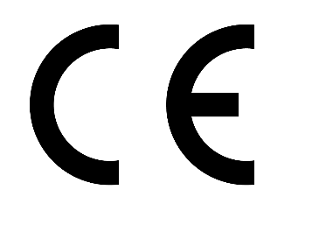
Low-voltage PSC Assembly:

COMPANY NAME
COMPANY ADDRESS

declare under our sole responsibility, for the equipment described above, is in conformity with the relevant Union harmonisation legislation:

Directive 2014/35/EU (Low-voltage) - Referring safety objectives as Article 3
Directive 2014/30/EU (Electro-magnetic compatibility) - Essential requirements as Annex I

and that the equipment is in conformity with the following harmonised standard:
BS EN 61439-2 Low-voltage switchgear and controlgear assemblies – Part 2: Power switchgear and controlgear assemblies

Place and date of issue:
COMPANY ADDRESS

Signed for and on behalf of COMPANY NAME:

____________________________

SIGNATURE DETAILS

